Centralised Retirement Proposition
May 2020

This document provides a structured, governed approach to investing in retirement.

Introduction
This document provides a structured, governed approach to investing for clients in retirement – a Centralised Retirement Proposition.
The FCA has stated that when advice firms introduce CIPs they should… ‘Consider the needs and objectives of your target clients when designing or adopting a CIP’. It’s clear from this that a CIP (and therefore the retirement income equivalent) is broader than simply selecting an investment portfolio.
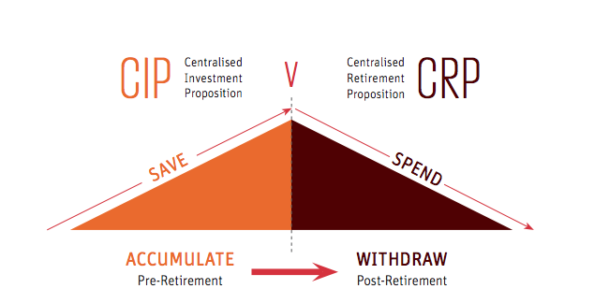
A CRP shares the same values and objectives as a CIP, but deals with more complex decisions, and risks, as the clients move from building wealth to generating a sustainable income in retirement.
The aim of this document is to create a structured investment advice process for retirement that aims to be consistent, repeatable and deliver suitable outcomes for different client segments.

Centralised Retirement Proposition Process
In addition to the client fact find, clients approaching or in retirement will go through the following process:
- Client Objectives
- Risk Assessment
- Withdrawal Options
- Investment Strategy
- Ongoing Review

1. Client Objectives
Key questions to answer include:
- When does the client want to retire?
- What lump sum do they want or need?
- How much income do they need?
- Do they want to leave a legacy?

2. Risk Assessment:
Key risks that will need to be addressed include, but are not limited to:
- Capacity for loss
- Longevity risk
- Investment risk
- Sequence risk
- Pound cost ravaging
- Mortality risk
- Inflation

3. Retirement Income Strategy
With the fact find and risk assessment completed, we will assess the relative funding position of the client’s retirement:
- Where a shortfall exists between a client’s secure income and their basic expenditure, we are likely to consider a ‘safety first approach’. This will involve using very low risk investments, such as cash or annuities, to meet the shortfall.
- Once a client’s essential expenditure has been secured, we are likely to consider an investment that has the opportunity for growth, particularly where growth is required to meet discretionary expenditure.
The below picture provides an illustrative example:

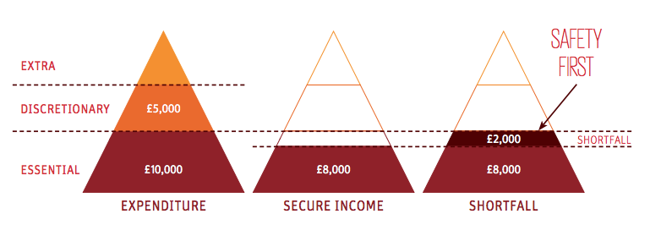
When arranging an income for retirement, we will consider all available options. The below table summarises the main options and outlines when they may be appropriate.
Income Strategy | Likely to be used when | Unlikely to be used when
Tax-free cash withdrawal | - The client requires a lump sum and does not have other more tax efficient sources to withdraw the funds from. | - The client has more tax-efficient sources to meet their funding needs.
Lifetime Annuities | - The client has no, or very limited capacity for loss and is not willing or able to bear investment risk.  - The client requires a secure income to meet their essential expenditure. | - The client has a medium or high capacity for loss and is willing and able to bear investment risk.  - The client already has sufficient secure income to meet their essential expenditure.
Guaranteed Income Products. | - The client has a low capacity for loss and is willing and able to bear some investment risk.  - The client values the guarantee that their capital is protected but wants to have the option of some capital growth | - The client is very conscious of costs and wants to keep their investing costs to a minimum  - The client has a medium or high capacity for loss and is willing and able to bear investment risk.
Fixed term annuities | - The client requires a set regular payment over a fixed period of time  - The client wants a fixed maturity value at the end of the plan term  - The client has no, or very limited capacity for loss and is not willing or able to bear investment risk. | - The client has a medium or high capacity for loss and is willing and able to bear investment risk.  - The client already has sufficient secure income to meet their essential expenditure.
Flexi-Access Drawdown | - The client has a medium or high capacity for loss and is willing and able to bear investment risk.  - The client already has sufficient secure income to meet their essential expenditure.  - The client agrees to an ongoing review service to manage the risks and ensure the solution remains suitable for their needs. | - The client has no, or very limited capacity for loss and is not willing or able to bear investment risk.
Partial encashment (UFPLS) | - The client wishes to withdraw tax-free cash and taxable income, and their current scheme does not facilitate flexi-access drawdown.  - The client’s highest priority is to make the most of their lifetime allowance and the client wants to take a mix of income and PCLS. This is because, in calculating the extent of the use of the lifetime allowance, HMRC allows rounding down of the percentage used. A flexi-access payment of income and PCLS involves two rounding’s down, while UFPLS allows just one. | - The client wants to minimise the tax liability of the withdrawal and this could more efficiently be met with another retirement option (i.e. tax-free cash under flexi-access drawdown).  - The client intends to continue making pension contributions in excess of the money purchase annual allowance.  - The clients existing scheme facilitates flexi-access drawdown.
Although the above table provides a guideline for retirement income planning, the recommended retirement income strategy will be determined by their needs and objectives.

4. Withdrawal Options
One of the main concerns of using drawdown of UFPLS is the fear that the fund could become prematurely exhausted and the income will dry up. The below text states our views on withdrawal options for managing this risk:
  - Total return vs. Natural Income
Although withdrawing natural income has the advantage of ensuring the portfolio is not depleted, research has shown that total return is a superior withdrawal method to natural income,,,. We will therefore recommend that clients withdraw funds on a total-return basis.
  - Income Sustainability – Withdrawal Rate
Research has shown that the ‘safe’ withdrawal rate is between 2 to 4%, depending on a number of factors. To mitigate the risk of clients depleting their portfolio, we will use the academic evidence to advise them on a sensible withdrawal rate. In addition to this:
- The Timeline application will be used to help illustrate the risks of withdrawing too much income.
- An individual Withdrawal Policy Statement will be provided to all clients.
- It will be mandatory for any clients who are using flexi-access drawdown to receive ongoing reviews.
  - Cash reserve strategy
Research has shown that holding a cash reserve in a retirement portfolio does not improve portfolio longevity,,. We will therefore not recommend that a client holds surplus cash in their portfolio beyond what is required to meet ongoing charges. We will however recommend that a client holds cash funds outside of the portfolio to cover short-term expenditure and unexpected costs (i.e. an emergency fund).
  - Flexible Withdrawals
Research has shown that clients can significantly reduce the chance of depleting their portfolio by adopting flexible withdrawal strategies,. We will educate clients on the need to be flexible with their withdrawals and use the Timeline application to illustrate the potential benefits of this.

5. Investment Strategy
If it has been determined that a client should remain invested, a suitable investment strategy needs to be selected. The investment strategy selected should aim to minimise the key risks for retirees previously mentioned.
5.1 Asset Classes
There is a claim that some asset classes, such as absolute return, can deliver equity like market returns with reduce downside volatility. This theory is not supported by evidence, therefore we will be using ‘traditional’ asset classes, such as equity, bonds and property, which have stood the test of time.
  - Asset Allocation
Research has shown that higher equity allocation tends to support higher withdrawal rates,. We will therefore recommend that clients allocate as much of their portfolio to equity as they are willing and able to bear.
  - Goals Based (Bucketing)
Research has shown that clients are less likely to panic and make ill-informed changes to their portfolio when following a goals-based approach to investing. To facilitate goals-based investing, we will use several ‘buckets’ or ‘investment pots’ to differentiate the different objectives for each pot. Each pot may have a different investment strategy and level of risk applied, although the overall portfolio will be aligned to the client’s risk profile.
The below picture provides an illustrative example (note that the “cash” bucket will typically be outside of the portfolio, held in the clients bank account).
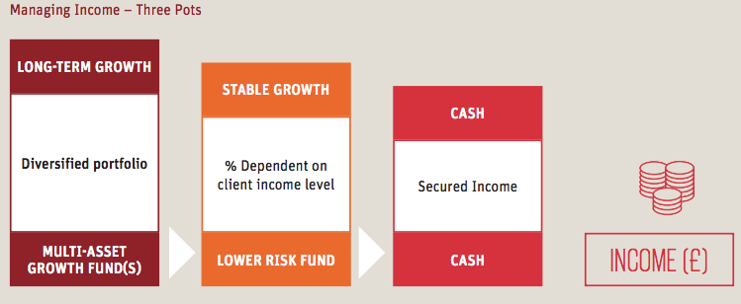
  - Active/Passive
Research has shown that over the long-term, active investments are more likely to underperform passive investments. We will therefore recommend that clients invest passively,.
  - Rebalancing
Research has shown that there is no optimal frequency or threshold when selecting a rebalancing strategy. We will therefore recommend that clients rebalance their portfolios twice per year. This is designed to minimise portfolio drift whilst keeping trading costs down.
  - Inhouse / Outsourced
We do not believe that we have the time, skills or expertise to manage advisory portfolios in house. We believe that outsourcing the management of investment portfolios to a specialist provider is likely to result in better client outcomes. Therefore, we have decided to outsource the investment management.
  - Options Discounted
Bespoke Investment Solutions
We have decided against a bespoke investment solution for clients in retirement as it is likely to prove challenging to develop a robust and repeatable process, that demonstrates good governance and delivers good outcomes for clients.

https://institutional.vanguard.com/iam/pdf/VIPS_total_return.pdf
https://www.synaptic.co.uk/research-and-opinion/connection/q2-2017/natural-yield-totally-bonkers-retirement-income-strategy
https://finalytiq.co.uk/natural-yield-totally-bonkers-retirement-income-strategy/
https://www.timelineapp.co/blog/putting-natural-yield-retirement-income-to-the-test/
https://www.langcatfinancial.co.uk/wp-content/uploads/2016/10/Aegon-HOW-TO-GET-YOUR-MONEY-BACK.pdf
https://finalytiq.co.uk/wp-content/uploads/2017/02/FPA-Journal-December-1997-Conserving-Client-Portfolios-During-Retirement-Part-III.pdf
https://www.onefpa.org/journal/Pages/Sustainable%20Withdrawal%20Rates%20The%20Historical%20Evidence%20on%20Buffer%20Zone%20Strategies.aspx
https://www.timelineapp.co/blog/cash-buffers-sustainable-withdrawal-and-bear-markets/?mc_cid=f50d0d3798&mc_eid=2ffa07a51e
Guyton, J.T. and Klinger, W.J., 2006. Decision rules and maximum initial withdrawal rates. JOURNAL OF FINANCIAL PLANNING-DENVER-, 19(3), p.48.
https://www.kitces.com/blog/dynamic-retirement-spending-small-but-permanent-variable-adjustments/
https://www.ii.co.uk/analysis-commentary/absolute-return-funds-once-again-fail-hit-target-ii507032
https://www.allocationblog.com/content/uploads/sites/3/2016/07/Equity-Gilt-Study-2016.compressed.pdf
https://finalytiq.co.uk/wp-content/uploads/2017/02/Bill-Bengen.pdf
https://finalytiq.co.uk/lower-equity-allocation-retirement-reducing-risk-shooting-foot/
http://citeseerx.ist.psu.edu/viewdoc/download?doi=10.1.1.335.236&rep=rep1&type=pdf
https://www.morningstar.com/content/dam/marketing/shared/Company/LandingPages/Research/Documents/Morningstar_Active_Passive_Barometer_2018.pdf
https://us.spindices.com/spiva/#/reports
https://www.vanguard.com/pdf/icrpr.pdf

