**August**

18

**Frazer James, Square Works, 17 Berkeley Square, Bristol BS8 1HB**

08

**Fall**

Capital Market Assumptions & System Preferences

This document outlines our capital market assumptions and preferences for cash flow planning.

Table of Contents

Capital Market Assumptions 3

System Assumptions 4

System Preferences 4

References 5

Appendix 7

1. Inflation 7

2. Cash 8

3. Asset Class Projections 9

4. Portfolio Return Projections 11

5. Life Expectancy 12

6. Property 16

7. Average Earnings 21

8. Tax Allowances (Core) 22

9. Tax Allowances (Other) 25

# Capital Market Assumptions

|  |  |  |  |
| --- | --- | --- | --- |
| **Category** | **Indicator** | **Default Assumption\*** | **Rationale** |
| Asset Class Projections | Inflation | CPI – 2.00%  RPI – 2.80%  Default – 2.80% | See Appendix. |
| Cash | 1.50% (Nominal) |
| Fixed Interest | 3.00% (Nominal) |
| Property Funds | 6.00% (Nominal) |
| UK Equities | 6.25% (Nominal) |
| Developed Market Equities | 6.50% (Nominal) |
| Emerging Market Equities | 8.00% (Nominal) |
| Small Cap & Value Equities | 8.00% (Nominal) |
| Portfolio Projections (net of all charges) | Risk 1 | RPI – 2.3% |
| Risk 2 | RPI -0.5% |
| Risk 3 | RPI |
| Risk 4 | RPI + 0.5% |
| Risk 5 | RPI + 1.0% |
| Risk 6 | RPI + 1.5% |
| Risk 7 | RPI + 2.0% |
| Risk 8 | RPI + 2.5% |
| Risk 9 | RPI + 2.5% |
| Risk 10 | RPI + 3% |

# System Assumptions

|  |  |  |
| --- | --- | --- |
| **Category** | **Default Assumption\*** | **Rationale** |
| Life expectancy | Couples - age 100  Individuals – age 95 | There’s a 1 in 4 chance that one person in a couple will be alive at age 100.  There’s a 1 in 4 chance that an individual will live to age 95 (see appendix).  Life expectancy adjusted dependent on clients circumstances / health / views |
| Property Prices | 4.00% (Nominal)  1.20% (Real) | Property historically has delivered a positive real return. The real return is likely to be lower in the future. |
| Rental Income | 2.80% (Nominal)  0.00% (Real) | Data for rental income supports projected growth in line with inflation. |
| Salary Growth Rate | 3.75% (Nominal) [1]  0.95% (Real) | Average earnings over the past 20 years. |
| Tax Allowances (Core) | 2.80% (Nominal)  0.00% (Real) | Analysis based on past allowance increases. |
| Tax Allowances (Other) | Pension/MPAA – 0.00%  LTA – CPI from 18/19  R/NRB – CPI from 2021/22  EIS/VCT – 0.00% | Based on current legislation and analysis of past allowance increases. |

# System Preferences

|  |  |  |
| --- | --- | --- |
| **Category** | **Default Assumption\*** | **Rationale** |
| Reinvest investment yield | Yes | Our investment philosophy is a total-returns approach to investing with income/dividends reinvested. |
| Spending order | 1st – Taxable  2nd – Tax free  3rd – Tax deferred | This is the most tax-efficient spending order for assets. |
| Save excess income | No | Saving surplus income creates a risk that the clients plan relies on saving income they don’t intend to or actually save. |
| Account Fees | 0.00% | None stated as benchmark return figures are net of all charges. |
| Life insurance proceeds | Invested | Where an individual receives a lump sum proceed from life insurance, it is assumed that surplus funds will be invested.  Funds are assumed to be invested as the individual will want to protect the proceeds from being eroded by inflation over the long-term. |

*\* Where clients exhibit a different behaviour or have a different view to the default assumptions, adjustments will be made.*

# References

Allocation Blog (2016) Barclays Equity & Gilt Study 2016 <https://www.allocationblog.com/content/.../3/.../Equity-Gilt-Study-2016.compressed.pdf>

Cox (2015) <https://professionaladviser.com/digital_assets/8871/Paul_Cox_Report.pdf>

Dimensional (2018) Pursuing a Better Investment Experience

Finalytiq (2016) <https://finalytiq.co.uk/longevity/>

FCA (2017) Rates of return for FCA prescribed projections <https://www.fca.org.uk/publication/research/rates-return-fca-prescribed-projections.pdf> s

House of Commons (2018) <http://researchbriefings.files.parliament.uk/documents/CBP-7671/CBP-7671.pdf>

Inflation Matters (2018) <http://inflationmatters.com/much-cpi-underestimates-inflation/>

Knight Frank (2018) UK RESIDENTIAL MARKET FORECAST <https://content.knightfrank.com/research/367/documents/en/uk-housing-market-forecast-may-2018-5544.pdf>

Knight Frank (2015) FOCUS ON: BATH AND BRISTOL 2015 <https://content.knightfrank.com/research/901/documents/en/2015-3170.pdf>

Land Bay (2018) The National Rent Review December 2017 <https://rentcheck.landbay.co.uk/wp-content/uploads/2017/12/7863_Landbay_NRR_2017_FINAL-1.pdf>

Land Registry (2018) House Price Statistics <http://landregistry.data.gov.uk/app/ukhpi/browse?from=1997-01-01&location=http%3A%2F%2Flandregistry.data.gov.uk%2Fid%2Fregion%2Funited-kingdom&to=2017-12-01>

Miller (2011) <http://obr.uk/docs/dlm_uploads/Working-paper-No2-The-long-run-difference-between-RPI-and-CPI-inflation.pdf>

Money Marketing (2016) <https://www.moneymarketing.co.uk/issues/23-june-2016/46-paul-lewis/>

ONS (2015a) Life Expectancy <https://www.ons.gov.uk/peoplepopulationandcommunity/birthsdeathsandmarriages/lifeexpectancies/articles/howlongwillmypensionneedtolast/2015-03-27>

ONS (2018b) Earnings – Labour Market Statistics <https://www.ons.gov.uk/employmentandlabourmarket/peopleinwork/earningsandworkinghours/timeseries/kac3/lms>

Positive Money (2018) <http://positivemoney.org/issues/house-prices/>

Nationwide (2018) House Price Index Data <https://www.nationwide.co.uk/about/house-price-index/download-data#xtab:uk-series>

Salomons and Grootveld (2011) The Equity Risk Premium: Emerging versus Developed Markets <http://citeseerx.ist.psu.edu/viewdoc/download?doi=10.1.1.476.814&rep=rep1&type=pdf>

Value Investor (2018) Why UK property prices could stay flat for 20 years <https://www.ukvalueinvestor.com/2018/06/uk-shares-uk-property-better-value.html/>

# Appendix

## Inflation

Both RPI and CPI measure inflation. Both of them do it by taking a basket of goods – food, clothes, and petrol - looking at what they cost last year, looking at what they cost now, and finding the proportional difference.

But the CPI leaves the costs of your home out of the basket – so rises in mortgage payments, rents, and council tax, which in real life you pay, don’t get reflected in it. The RPI does take account of those costs.

CPI usually underestimates RPI as it does not include housing elements and it is calculated differently (Inflation Matters 2018). Between 1989 and 2011 Retail Prices Index (RPI) inflation tended to be around 0.7 percentage points higher than Consumer Prices Index (CPI) inflation on average. (Miller, 2011).

The majority of clients having housing costs, therefore RPI has been selected as the primary inflation measure.

To measure inflation, the ONS data source has been used:

RPI - <https://www.ons.gov.uk/economy/inflationandpriceindices/timeseries/czbh/mm23>

CPI - <https://www.ons.gov.uk/economy/inflationandpriceindices/timeseries/d7g7/mm23>

A timeframe of the most recent 20 years, measured on a rolling basis, has been used as:

1. There have been large changes in inflation over the very long period. The high-inflationary environment of the 1980s appears to be an anomaly in the long-run data set and including this is likely to overstate the inflation rate that clients will experience.
2. Data from the ONS for CPI is restricted to 29 years (1989 – 2017)

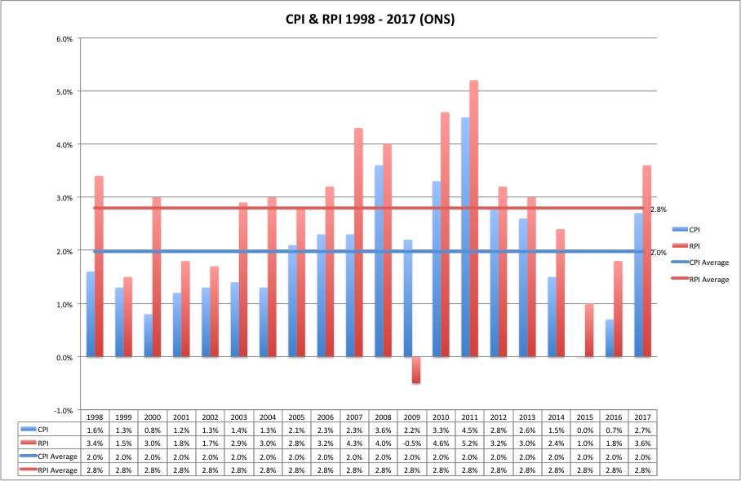

## Cash

Over the long-term, cash (defined as the interest rate received on Building Society savings) has delivered a positive real return. The table below uses data from the Barclays Equity Gilt Study 2016, measuring returns of different asset classes to the end of 2016 (Allocation Blog, 2016).

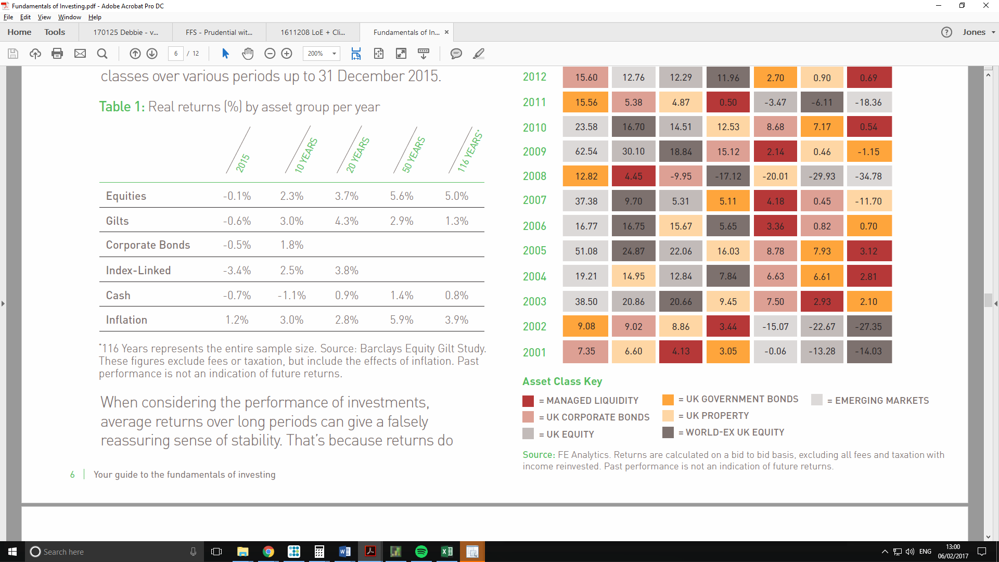

Over the last 10 years, cash has delivered a negative real return. This is partly because of low interest rates, which have reduced the interest rate available on cash savings.

When considering the role of cash in client’s portfolios, cash is most likely used to cover short-term expenditure. Cash is therefore likely to be held in an easy or instant access current or savings account and is unlikely to benefit from higher interest rates available for fixed-rate bonds.

If clients constantly change their savings account provider, it is possible for cash to deliver a positive real return in most years (Money Marketing, 2016). The experience with clients has been that they are unlikely to constantly change their savings account provider and instead are more likely to stick with their current provider, even when this provides them with a lower interest rate on their cash savings.

The view has been taken that client’s cash holdings are likely to underperform inflation by 1.50% per year.

## Asset Class Projections

In order to derive meaningful portfolio returns linked to clients risk appetites over different timeframes, it is necessary to establish assumed returns into the future for the major assets classes. These are cash, gilts, corporate bonds, property and equities. The Barclays Capital Equity Gilts study and the PwC September 2017 paper both provide good source data for this exercise.

The PwC 2017 paper provides more granularity as it looks not only at gilts and equities but also at other classes, including corporate bonds, property and cash deposits. Moreover it is commissioned by the Financial Conduct Authority in order to provide projection rates for financial services companies to use in their calculations when providing retail clients with projections of future benefits. It is the fourth iteration of the review, previous studies having been published in 2003, 2008 and 2012. The report was commissioned to provide intermediate returns using a base case portfolio. Its relevance is clear.

|  |  |
| --- | --- |
|  | **2017 Report Range** |
| Nominal Government Bonds | 1.5% to 2.5% |
| Nominal Equity Returns | 5.5% to 7.5% |
| Nominal Corporate Bond Returns | 2.6% to 3% |
| Nominal Property Returns | 5% to 6% |
| Nominal Cash and Money Markets Returns | 1% to 2% |

The PWC/FCA report did not distinguish between different classes of equities. There is a large swathe of evidence that states that:

1. Smaller cap and value equities outperform large cap and growth equities over the long-term. We have therefore projected a higher rate of return for these types of asset classes than other types of equities (Dimensional, 2018).

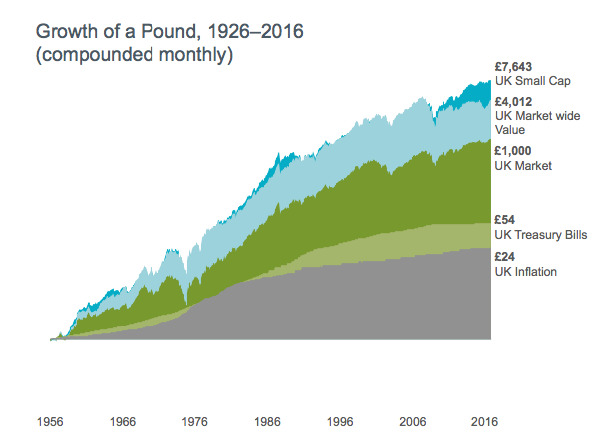

1. Emerging market equities outperform developed market equities over the long-term. We have therefore projected a higher rate of return for these types of assets over other types of equities (Salomons and Grootveld, 2011)

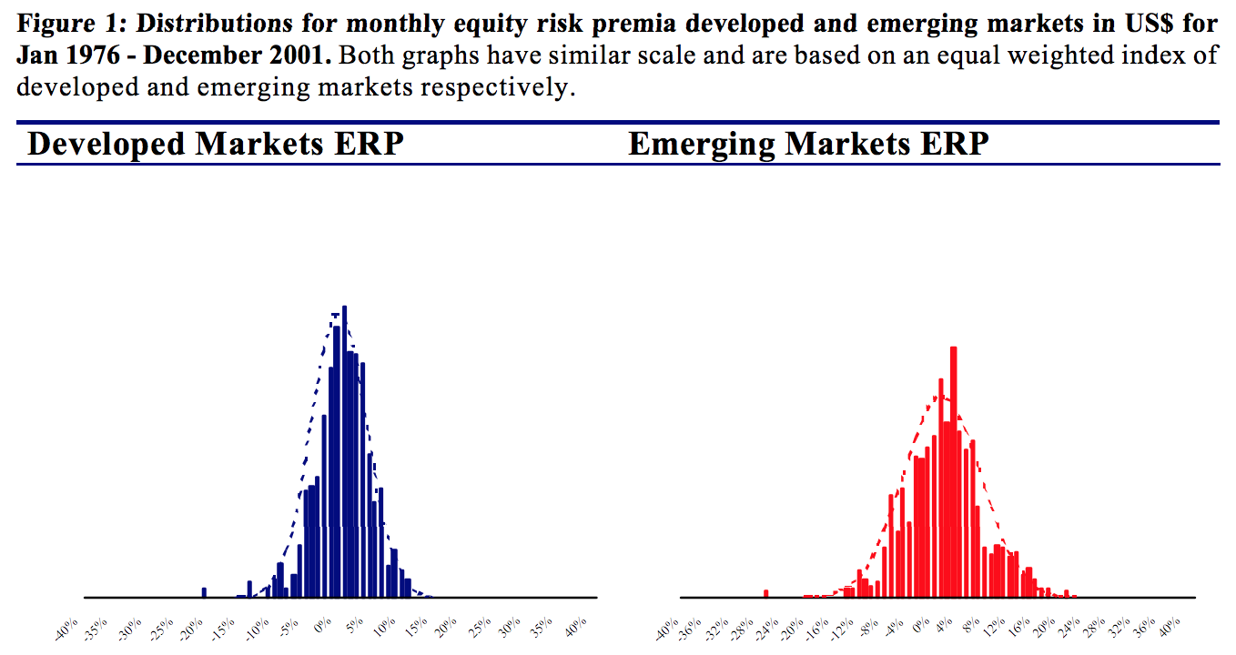

We have therefore updated the projection rates to include these different types of asset classes. The projection rates used are:

|  |  |
| --- | --- |
|  | **Nominal Projection Rates** |
| Managed Liquidity (Cash) | 1.50% |
| Fixed Interest | 3.00% |
| Property | 6.00% |
| UK Value and Income Equity | 6.25% |
| UK Growth | 6.25% |
| Developed Markets Equity | 6.50% |
| Emerging Markets | 8.00% |
| Small Cap & Value | 8.00% |

## Portfolio Return Projections

Using the asset class return assumptions, the below table projects the rate of return on different risk-rated portfolios:

|  |  |  |  |  |  |  |  |  |  |  |
| --- | --- | --- | --- | --- | --- | --- | --- | --- | --- | --- |
| **Name** | **Risk 1** | **Risk 2** | **Risk 3** | **Risk 4** | **Risk 5** | **Risk 6** | **Risk 7** | **Risk 8** | **Risk 9** | **Risk 10** |
| Managed Liquidity | 100% | 45% | 25% | 10% | 0% | 0% | 0% | 0% | 0% | 0% |
| Fixed Interest | 0% | 40% | 45% | 50% | 50% | 45% | 35% | 25% | 20% | 10% |
| Property | 0% | 5% | 10% | 10% | 10% | 5% | 5% | 5% | 0% | 0% |
| Global Equity | 0% | 4% | 6% | 10% | 12% | 14% | 16% | 18% | 20% | 22% |
| Global Equity Small Cap & Value | 0% | 6% | 9% | 15% | 18% | 21% | 24% | 27% | 30% | 33% |
| Emerging Markets Equity | 0% | 0% | 3% | 3% | 5% | 8% | 10% | 13% | 15% | 18% |
| Emerging Markets Small Cap & Value Equity | 0% | 0% | 2% | 2% | 5% | 7% | 10% | 12% | 15% | 17% |
|  |  |  |  |  |  |  |  |  |  |  |
| Gross return | 1.50% | 2.98% | 3.88% | 4.61% | 5.23% | 5.53% | 6.00% | 6.46% | 6.78% | 7.23% |
| RPI | 2.80% | 2.80% | 2.80% | 2.80% | 2.80% | 2.80% | 2.80% | 2.80% | 2.80% | 2.80% |
| Fund + Platform Costs | 0.50% | 0.48% | 0.50% | 0.51% | 0.54% | 0.57% | 0.62% | 0.65% | 0.69% | 0.72% |
| Adviser charges | 0.50% | 0.50% | 0.50% | 0.50% | 0.50% | 0.50% | 0.50% | 0.50% | 0.50% | 0.50% |
| **Net Real Return** | **-2.30%** | **-0.81%** | **0.08%** | **0.79%** | **1.39%** | **1.66%** | **2.08%** | **2.51%** | **2.79%** | **3.21%** |
|  |  |  |  |  |  |  |  |  |  |  |

## Life Expectancy

Cohort / Period Life Expectancy

1. Period life expectancy – this shows life expectancy in a given period eg as at 2015, for differing years of birth.
2. 2. Cohort life expectancy– this tracks the experience of a given cohort who shares the same year of birth year after year and takes into account known and predicted improvements in mortality. Projections of cohorts are based on extrapolation of past trends in mortality improvement and expert opinion about future trends.

The ONS believes that cohort life expectancy is a better measure of how long a person of a given age is expected to live

Underestimating Life Expectancy

There’s a gap of two to seven years between how long consumers think they’re going to live and how long experts believe they’re actually going to live. (Cox, 2015)

Survival Probability (Female)

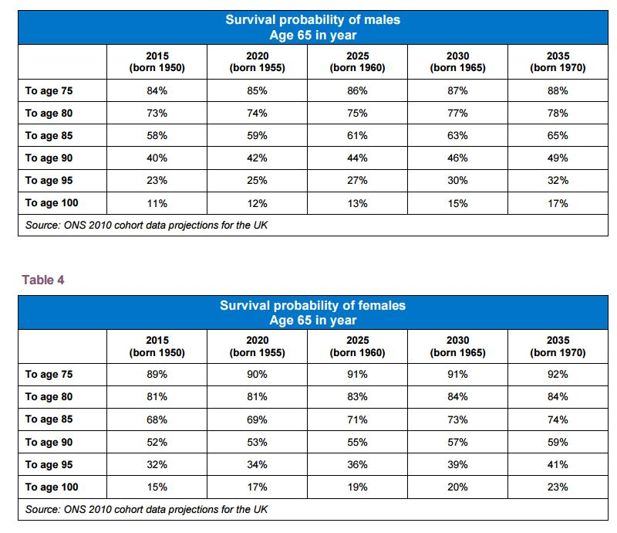

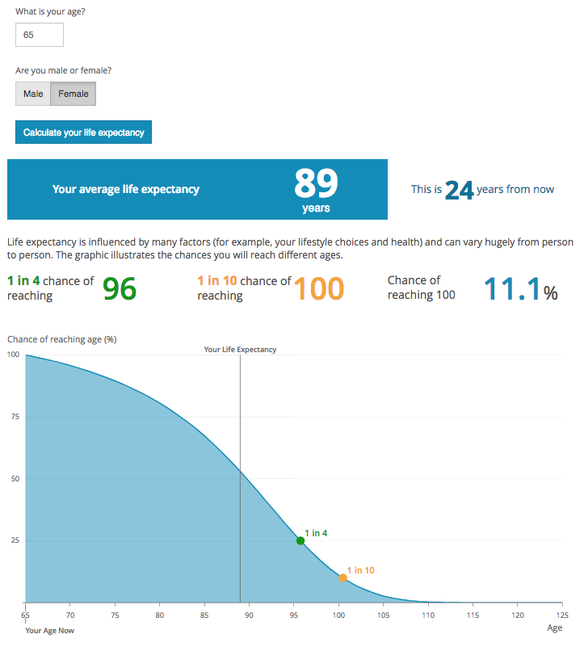

Survival Probability Male



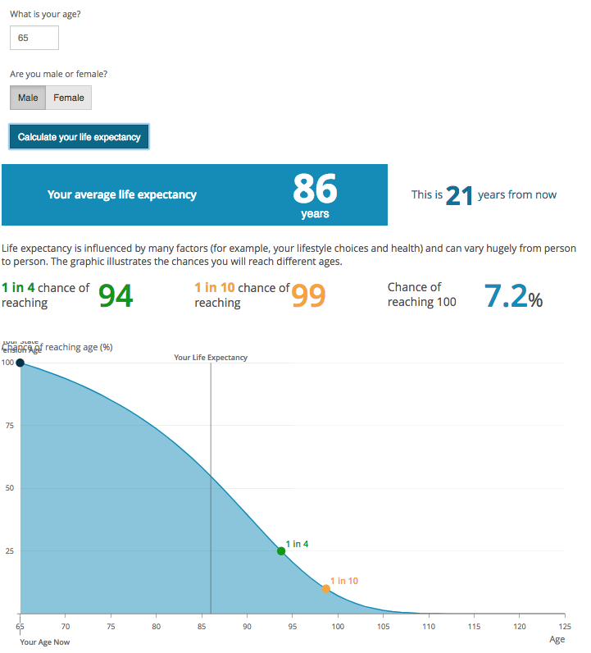

Survival Probability (Couple)

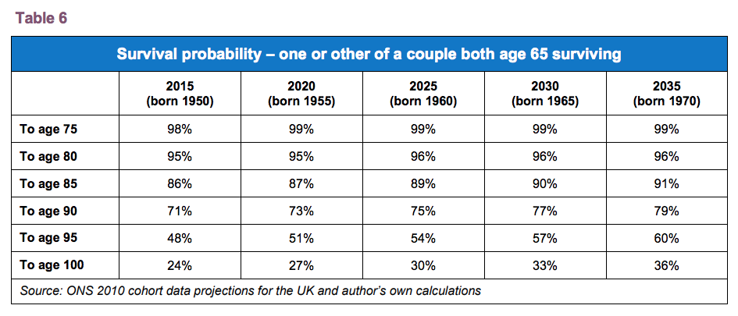

Survival Probability at Age 65, born in 1950 (Couple)

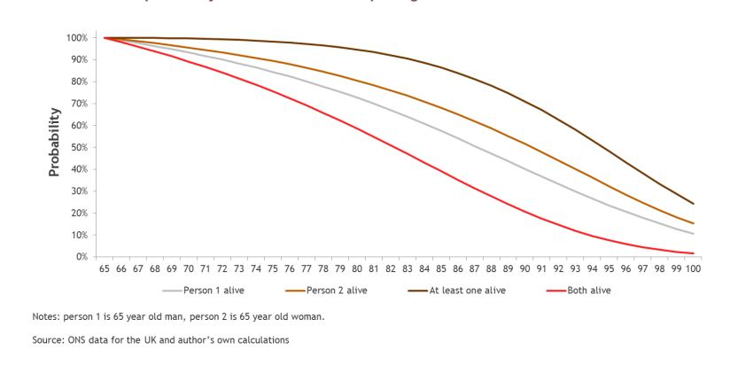

(Cox, 2015) (Finalytiq, 2016) (ONS, 2015)

## Property

**Property Price Growth**

Measured over 20 years, the average property in the UK has delivered a nominal return of 6.8% per annum (Land Registry, 2018) (Nationwide, 2018).



In the short-term (0 – 5 years), it is our view that property prices will match inflation. Political risk (Brexit), combined with rising interest rates and the introduction of additional property tax charges (SDLT) are likely to reduce property price growth in the short-term when compared to the long-run growth prospects. This view is shared by Knight Frank in their UK Residential Market Forecast (2018):

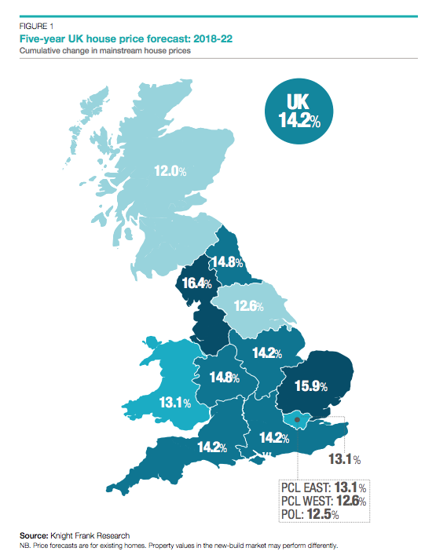

In the medium to long-term (5+ years), it is our view that property prices will exceed inflation by 1.00%. This is lower than the 3.00% real return delivered by property over the past 20 years. Reasons for this include:

1. Relative to earnings, house prices are expensive (Value Investor, 2018). When house prices become less affordable, fewer individuals will be able to purchase houses, resulting in diminished demand.

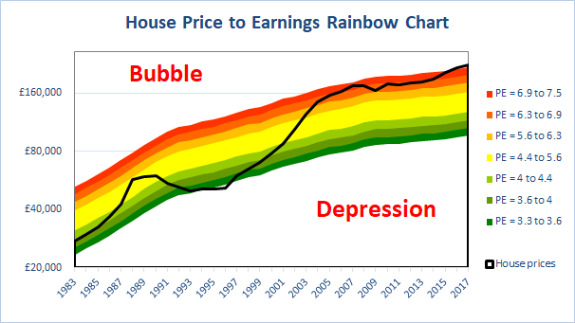

1. Fewer individuals can afford to meet the monthly mortgage payments (Positive Money, 2018). This situation is likely to intensify further when interest rates increase.

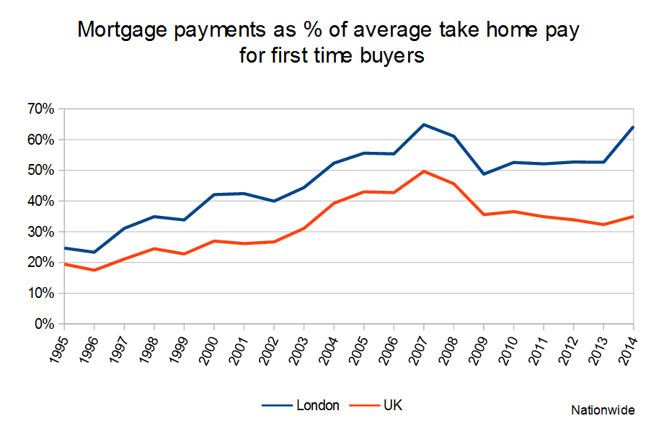

Based on the above, it is our view that property prices are not likely to exceed inflation by as much as they have in the past. We do however believe that property prices are likely to continue to exceed inflation as:

1. There is an undersupply of new houses relative to the needs created by population growth (House of Commons 2018). Despite continued shortages, structural issues in the property market means that this is unlikely to be resolved in the short-medium term and therefore deliver a real return.

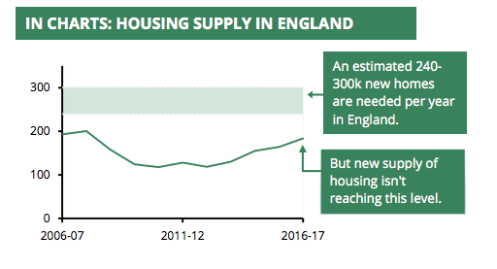

**Rental Income Growth**

Rental growth in the UK has slowed considerably in recent years, from a high of around 3% per annum to 0% per annum for the twelve months up to December 2017 (Landbay, 2018).

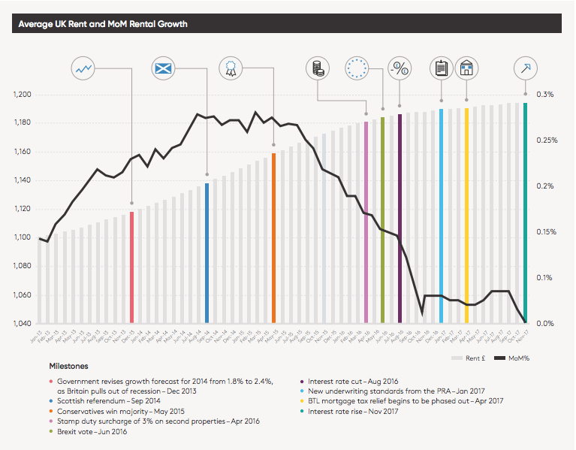

The slowdown in rental growth has not been consistent across the country. For the year ending 2017, the South West, where the majority of our clients are likely to have rental properties, experienced rental income growth of (1.63%), whereas London rents fell by -0.83% (Landbay, 2018).

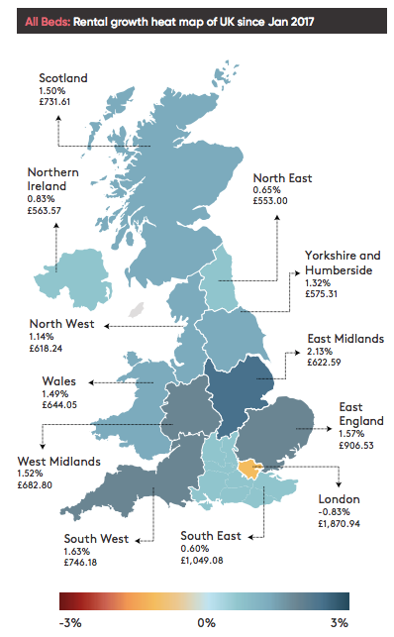

Within the South West, Bristol delivered rental income growth of 2.69%. Reasons for higher rental income in Bristol compared to the South West and the UK include (Knight Frank, 2015):

1. Improved transport links between Bristol and London
2. Extension and development plans for Bristol Airport
3. The relative price discount in Bristol compared to London
4. A well-established and growing industrial hub for aerospace engineering, microelectronics, digital and tech.

We therefore believe that clients with properties in the Bristol area are likely to see rental income growth in line with inflation (RPI). Rental income growth for clients with properties outside of the Bristol area will be evaluated on a case-by-case basis.

## Average Earnings

Data from ONS (2018b) shows that Average Earnings over the past 20 years has been 2.8%:

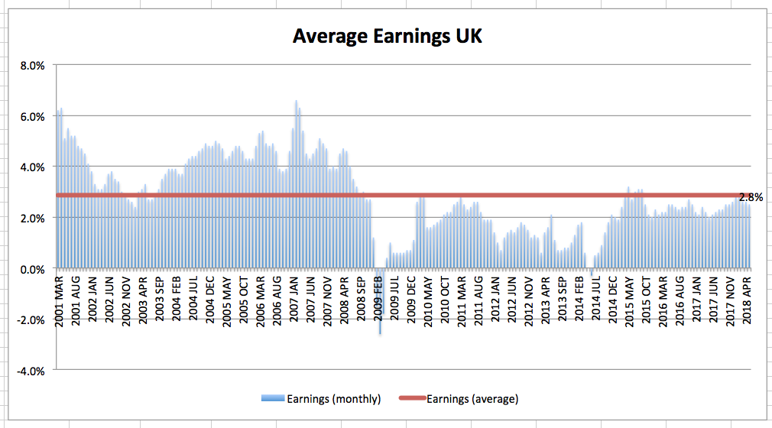

In the last five years, earnings growth has been weaker than than the pre-crisis average growth of 4%.

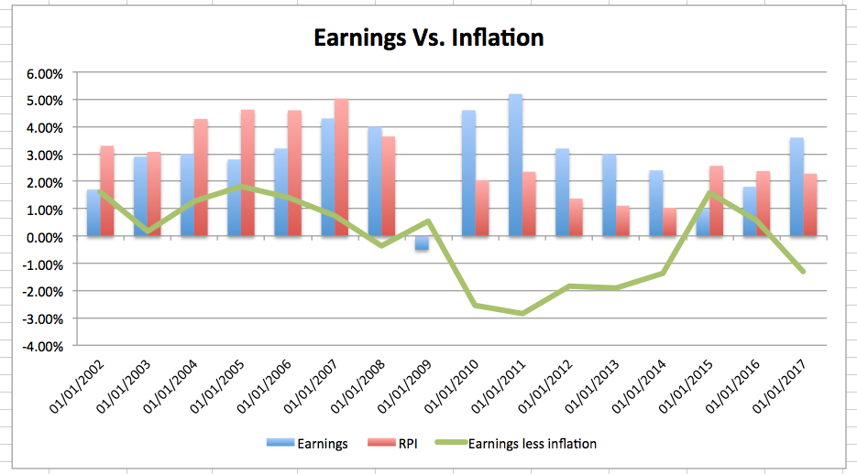

With the current unemployment rate very low (4.7%), the absence of wage inflation points to a lower long-run unemployment rate. The Bank of England has recently estimated that the long-run unemployment rate has decreased from 5% to 4.5%. This and the current unemployment rate suggest that there is little slack in the labour market.

As this slack is absorbed, earnings growth is estimated to pick up. We expect long-run earnings to be around 4.25%. However, we recommend a lower average earnings growth estimate of 3.75% for the next 10-15 years due to anticipated lower earnings growth in the short term (FCA, 2017).

## Tax Allowances (Core)

The ‘tax table assumptions’ used in Voyant determines the increase applied to:

1. Personal Allowance Tax Allowance
2. Basic Rate Tax Band
3. Higher Rate Tax Band
4. Additional Rate Tax Band
5. Annual Income Threshold (phasing out of personal allowance)
6. Annual income threshold (for tapering pension contribution allowance)
7. ‘No-earnings’ pension contribution allowance
8. Capital Gains Tax Allowance
9. ISA Contribution Allowance

It is not possible to specify individual rates of increase for each of the above tax allowances.

Analysis of past allowances shows that allowances change at different rates:

|  |  |  |  |  |  |  |  |  |  |  |
| --- | --- | --- | --- | --- | --- | --- | --- | --- | --- | --- |
| **Increase Tax Allowances** | **2010/11** | **2011/12** | **2012/13** | **2013/14** | **2014/15** | **2015/16** | **2016/17** | **2017/18** | **2018/19** | **Average** |
| Personal Allowance (1) | £6,475 | £7,475 | £8,105 | £9,440 | £10,000 | £10,600 | £11,000 | £11,500 | £11,850 |  |
| Personal Allowance Increase |  | 15.44% | 8.43% | 16.47% | 5.93% | 6.00% | 3.77% | 4.55% | 3.04% | 7.95% |
|  |  |  |  |  |  |  |  |  |  |  |
| Basic Rate Band - up to (2) | £37,400 | £35,000 | £34,370 | £32,010 | £31,865 | £31,785 | £32,000 | £33,500 | £34,500 |  |
| Basic Rate Increase |  | -6.42% | -1.80% | -6.87% | -0.45% | -0.25% | 0.68% | 4.69% | 2.99% | -0.93% |
|  |  |  |  |  |  |  |  |  |  |  |
| Higher Rate - up to (3) | £150,000 | £150,000 | £150,000 | £150,000 | £150,000 | £150,000 | £150,000 | £150,000 | £150,000 |  |
| Higher rate increase |  | 0.00% | 0.00% | 0.00% | 0.00% | 0.00% | 0.00% | 0.00% | 0.00% | 0.00% |
|  |  |  |  |  |  |  |  |  |  |  |
| Threshold income for PA reduction | £100,000 | £100,000 | £100,000 | £100,000 | £100,000 | £100,000 | £100,000 | £100,000 | £100,000 |  |
| Threshold income for PA reduction |  | 0.00% | 0.00% | 0.00% | 0.00% | 0.00% | 0.00% | 0.00% | 0.00% | 0.00% |
|  |  |  |  |  |  |  |  |  |  |  |
| **CGT Allowances** |  |  |  |  |  |  |  |  |  |  |
| Individual CGT Allowance (4) | £10,100 | £10,600 | £10,600 | £10,900 | £11,000 | £11,100 | £11,100 | £11,300 | £11,700 |  |
| CGT Increase |  | 4.95% | 0.00% | 2.83% | 0.92% | 0.91% | 0.00% | 1.80% | 3.54% | 1.87% |
|  |  |  |  |  |  |  |  |  |  |  |
| **Pension Allowances** |  |  |  |  |  |  |  |  |  |  |
| Non-earnings pension allowance (5) | £3,600 | £3,600 | £3,600 | £3,600 | £3,600 | £3,600 | £3,600 | £3,600 | £3,600 |  |
| Non-earnings increase |  | 0.00% | 0.00% | 0.00% | 0.00% | 0.00% | 0.00% | 0.00% | 0.00% | 0.00% |
|  |  |  |  |  |  |  |  |  |  |  |
| **ISA Allowances** |  |  |  |  |  |  |  |  |  |  |
| Overall ISA Subscription Limit (6) | £10,200 | £10,680 | £11,280 | £11,520 | £15,000 | £15,240 | £15,240 | £20,000 | £20,000 |  |
| CGT Increase |  | 4.71% | 5.62% | 2.13% | 30.21% | 1.60% | 0.00% | 31.23% | 0.00% | 9.44% |
|  |  |  |  |  |  |  |  |  |  |  |
| **National Insurance Allowances** | |  |  |  |  |  |  |  |  |  |
| Class 1 Primary Threshold (7) | £110 | £139 | £146 | £149 | £153 | £155 | £155 | £157 | £162 |  |
| Class 1 Increase |  | 26.36% | 5.04% | 2.05% | 2.68% | 1.31% | 0.00% | 1.29% | 3.18% | 5.24% |
|  |  |  |  |  |  |  |  |  |  |  |
| Class 2 + 4 Small Profits Threshold (7) | £5,075 | £5,315 | £5,595 | £5,725 | £5,885 | £5,965 | £5,965 | £6,025 | £6,205 |  |
| Class 2 + 4 Increase |  | 4.73% | 5.27% | 2.32% | 2.79% | 1.36% | 0.00% | 1.01% | 2.99% | 2.56% |
|  |  |  |  |  |  |  |  |  |  |  |
| 1. https://www.gov.uk/government/publications/rates-and-allowances-income-tax/income-tax-rates-and-allowances-current-and-past | | | | | | | | |  |  |
| 2. https://assets.publishing.service.gov.uk/government/uploads/system/uploads/attachment_data/file/709417/Table-a2.pdf | | | | | | | |  |  |  |
| 3. https://www.gov.uk/government/publications/rates-and-allowances-income-tax/income-tax-rates-and-allowances-current-and-past | | | | | | | | |  |  |
| 4. https://www.rossmartin.co.uk/private-client-a-estate-planning/capital-gains-tax/110-capital-gains-tax-rates-a-allowances | | | | | | | | |  |  |
| 5. http://webarchive.nationalarchives.gov.uk/20100104174903/http://www.hmrc.gov.uk/consult_new/pensions_consult.pdf | | | | | | | |  |  |  |
| 6. http://webarchive.nationalarchives.gov.uk/20100104174903/http://www.hmrc.gov.uk/consult_new/pensions_consult.pdf | | | | | | | |  |  |  |
| 7. https://www.gov.uk/government/uploads/system/uploads/attachment.../Table-a4.xls | | | | |  |  |  |  |  |  |
| 8. https://www.gov.uk/government/uploads/system/uploads/attachment.../Table-a4.xls | | | | |  |  |  |  |  |  |
|  |  |  |  |  |  |  |  |  |  |  |

We view this as a limitation of the software. To overcome this limitation, we have assumed an average rate of 2.80% (RPI) to be applied across all tax bands / allowances. This is considered a reasonable assumption as this is broadly in line with the 2.90% ‘average of averages’ from the different tax allowance

increase in the past.

A slight reduction to the 2.90% ‘average of averages’ has been applied as:

1. The majority of our target clients are unlikely to be affected by the non-earnings pension allowance as 80% of our clients will be in employment.
2. The majority of our target clients are unlikely to be affected by the threshold income for loss of personal allowance which has not increased over the period as their income is expected to be between £50,000 - £100,000.

## Tax Allowances (Other)

Shown below are the tax allowance assumptions used in Voyant:

1. **Nil Rate Band Escalation %** - This is set at £325,000 through 2020/21 (as per current legislation), and begins to escalate thereafter, as set using the Nil Rate Band Escalation of CPI (2.00%)

1. **Residence Nil Rate Band Escalation %** - The Residence Nil Rate Band is being phased in between 2017/18 and 2020/21. The software includes the phasing in of the RNRB. The software setting is to escalate the RNRB from 2021/22 in line with CPI, as per current legislation.
2. **Lifetime Allowance (LTA) Escalation %** - The software setting is to escalate the Lifetime Allowance from 2018/19 in line with CPI, as per current legislation.
3. **Pension Annual Allowance Escalation / MPAA – pensions annual allowance and the money purchase annual allowance has reduced considerably in recent years. The software has been programme not to escalate the pension annual allowance or MPAA. The software setting is to update the pension annual allowance / MPAA only when legislation is announced that makes changes to the annual allowance.**
4. **EIS/VCT -** the software does not escalate EIS and VCT contribution limits. We feel that this is appropriate, as contribution limits for these products have not historically increased.

1. A limitation of Voyant is that the State Pension escalation rate is set to escalate automatically by the triple lock: <https://support.planwithvoyant.com/hc/en-us/articles/211660743-State-Pension-in-future-value>

   There is no option to remove this triple lock, meaning that the State Pension will grow by 3.75% (the assumed national average earnings), whereas expenses grow by 2.80%.

   We do not believe that the triple lock is likely to remain indefinitely due to it being unaffordable. We believe that in the future, the State Pension will increase by a less generous rate, likely to be in line with RPI. By using NAE of 3.75%, there is therefore a risk that the State Pension appears to be more generous that it actually is.

   For this reason, we have assumed national average earnings of 2.80% in line with RPI, so that the State Pension only grows in line with earnings.